|  |
| --- |
|  |
| Embedded Systems |
| Lab 1 report |

|  |
| --- |
| Robert Nicoll (rn37@hw.ac.uk) |

Contents

Delay calculation 2

NAME (MS) DELAY 2

TIMER 1 DELAY 2

Task 1 3

Photo of completed circuit 3

Schematic 3

Code 4

Task 2 5

Photo of completed circuit 5

Schematic 5

Code 6

Task 3 7

Photo of completed circuit 7

Schematic 8

Design decisions 9

Timer initialization 9

Code 10

## Delay calculation

### NAME (MS) DELAY

Name calculation: ((N) 14 + (R) 18) * 100= 3200ms

Delay needed: 2700x10-3 = 3.2s

### TIMER 1 DELAY

ATMEGA328P Clock speed: 16MHZ

16x106x(1/256) = 62500HZ

1/62500H= 1.6x10-5

1.6x10-5 x 216

1.04s (TOO SMALL)

16x106x(1/1024) = 15625

1/15625 = 6.4x10-5

6.4x10-5 x 216

4.162s

Delay calculation:

16x106x(1/1024) = 15625

1/15625 = 6.4x10-5

3.2/6.4x10-5 = 50000

HEX: C350

BIN: 1100001101010000

## Task 1

### Photo of completed circuit

Schematic

### Code

; ATMEGA328P Clock speed: 16MHZ

; Delay: 2700x10^-3 = 2.7

;

; 16x10^6x(1/1024) = 15625

; 1/15625 = 6.4x10^-5

; 2.7/6.4x10^-5 = 42187.5

;

; 0xA4CA OR 0b1010010011001010

;

LDI R23, 0b11000011 ;load R23 with upper 8 bits of calculated delay value

STS OCR1AH,R23 ;load r23 into OCR1AH (HIGH must be written below OCR1AL)

LDI R23, 0b01010000 ;load R32 with the lower 8 bits of calculated delay values

STS OCR1AL,R23

LDI R16, 0b00000111

OUT DDRB, R16 ;PB0,PB1 and PB3 as outputs

LDI R16,0

LDI R17,0b1

OUT PORTB,R16 ;initialize all lamps as off

BEGIN: LDI R20,0x00

STS TCCR1A,R20

LDI R20, 0b01101

STS TCCR1B,R20 ;start ctc timer in 1/1024 mode

AGAIN: SBIS TIFR1,OCF1A ;wait till timer reaches threshold

RJMP AGAIN

LDI R20,0x00

STS TCCR1B,R20 ;Stop the timer

LDI R20,1<<OCF1A

OUT TIFR1,R20

OR R16,R17 ;do a or operation on R17 and R16 and save into R16 (so for the 1st look R16 goes from 0 to 0b00000001)

LSL R17 ;shift r17 to the lest one to allow the lamps to increment

OUT PORTB,R16 ;set the high bits in R16 to the PORTB to light the lamps

RJMP BEGIN

## Task 2

### Photo of completed circuit

### Schematic

### Code

/*

* Lab1.c

*

* Created: 03/10/2020 13:40:01

* Author : Robert Nicoll (rn37)

*/

#include<avr/io.h>

#include<avr/interrupt.h>

#define *F_CPU* 16000000UL

#include"util/delay.h"

const int inital = 14 +18 (9 + 18) * 100;

//37.03 x10^-3

//0.0370 x10^-6

int main(void)

{

DDRB=0xFF;

DDRB &= ~(1 << 5); //initialize IO pins

OCR1A = 0xC350; //initialize delay value

EIMSK = (1 << INT0); //setup interrupt 0 listening on pin 2 of arduino

sei();

while(1){} //do nothing while waiting on interrupt

}

ISR(INT0_vect){

//loop 3 times (for the 3 lamps)

for(int i = 0; i < 3; i++){

//set bit high bit high bit moves left every time for loop iterates

PORTB |= (1 << i);

//setup timer1 in CTC 1/1024 mode

TCCR1A = 0;

TCCR1B =0b01101;

//Do nothing till delay threshold is met

while ((TIFR1&(1<<OCF1A) )==0){

}

//stop timer1

TCCR1B =0;

TIFR1 = 1<<OCF1A;

}

//turn off lamps

PORTB=0b00;

}

## Task 3

### Photo of completed circuit

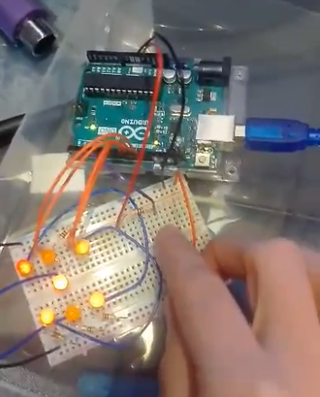

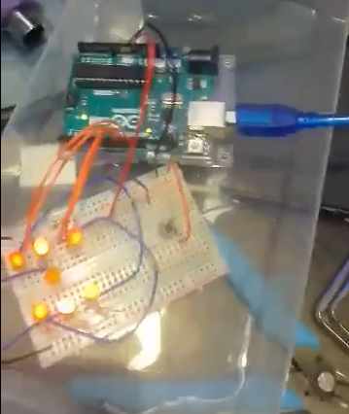

### Schematic

### Design decisions

When designing this circuit I decide LED1, LED2 and LED3 could share a resistor as all 3 will never be on at once LED 3 is the center dot only lighting for 1,3 and 5s. LED1 and 2 will only light for 6s. This allows me to save on resistors and wire connections for the circuit

I also decided to have LEDs wired in twos for the most part for the same reason all the lamps (bar the number 1) have to have the same 2 lamps illuminated to represent a number and using this method makes the software side a lot simpler and requires less pins to be used on the microcontroller

### Timer initialization

Before entering the main loop I set the timer1 register OCR1A to 0xC4CA as this value will be set and not change throughout the execution. I then also started the timer0 before the main loop as the counter is needed to correctly seed the random value

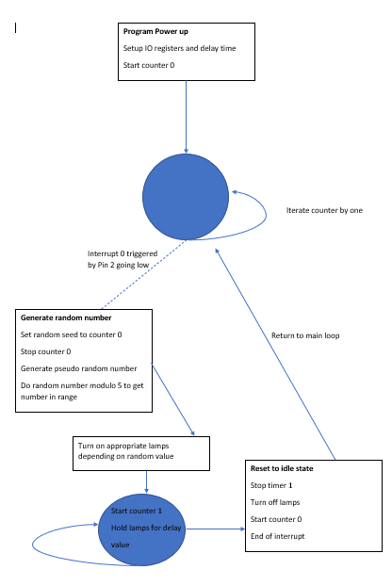

### Code

/*

* Lab1Part3.c

*

* Created: 16/10/2020 01:11:26

* Author : bear

*/

#include<avr/io.h>

#include<avr/interrupt.h>

#include<stdlib.h>

#define *F_CPU* 16000000UL

#include"util/delay.h"

const int inital = (9 + 18) * 100;

int main(void)

{

TCCR0A = 0;

TCCR0B = 0x05; //initialize timer for use as a counter for random seed

//

DDRB=0xFF;

DDRB &= ~(1 << 5); //setup IO pins

OCR1A = 0xA4CA; //Set timer1's delay value

EIMSK = (1 << INT0); //setup interrupt 0 and start listening for interrupt on pin 2

sei();

while(1){} //main loop (do nothing)

}

ISR(INT0_vect){

*srand*(TCNT0); //seed random generator with counter 0's value

TCCR0A = 0; //stop counter 0

TCCR0B = 0;

//--- generate random number and take its modulo to make it in the dice range then light the lamps according to the random value

switch(*rand*()%6)

{

case 0:

PORTB = 0b1;

break;

case 1:

PORTB = 0b10;

break;

case 2:

PORTB = 0b11;

break;

case 3:

PORTB = 0b1010;

break;

case 4:

PORTB = 0b1011;

break;

case 5:

PORTB = 0b1110;

break;

default:

PORTB = 0b1111;

}

//start timer 1 to hold value on the lamp display

TCCR1A = 0;

TCCR1B =0b01101;

while ((TIFR1&(1<<OCF1A) )==0){

}

//stop timer 1 once the delay length has been reached

TCCR1B =0;

TIFR1 = 1<<OCF1A;

//turn off lamp display

PORTB=0b00;

TCCR0A = 0;

TCCR0B = 0x05; //restart counter 0

}